Logbook / Report

Student Name: Precious Jaiyesimi Eniola
Admission number: BIT/2024/39050
Course: Mobile Application Development
School/Faculty: Computing and Informatics, Mount Kenya University_
Program: Information Technology
Academic Year: 4th
Semester: First
Lecturer: Mr Nyoro

Week 8

Task Completed
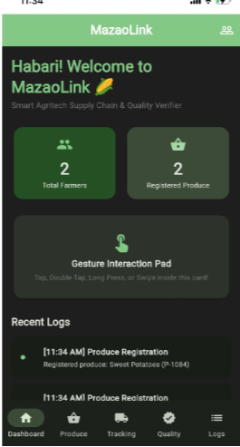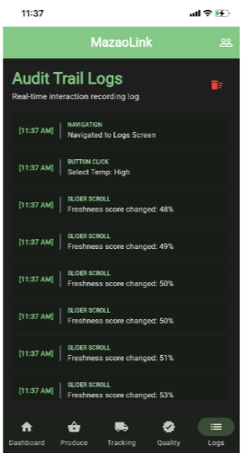

Dashboard Activities Tracking page

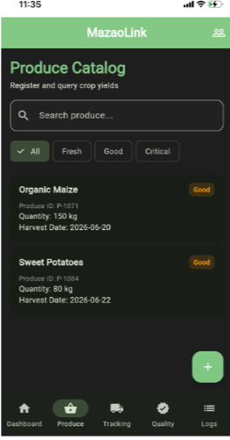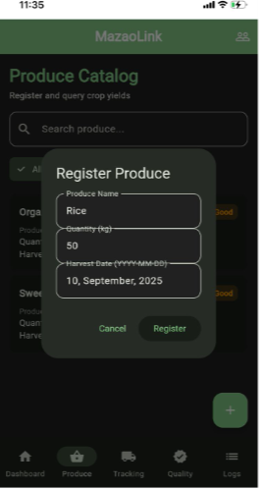
Produce Register Page

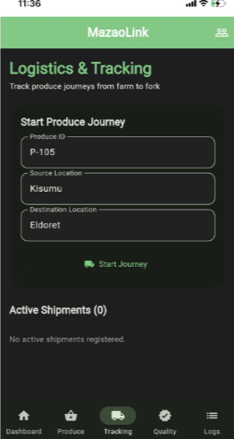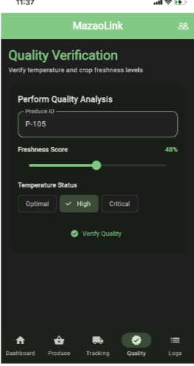
Logistics Quality Checking

Tools Used:
- Android Studio
- Visual Studio Code (VS Code)
- Flutter SDK
- Dart Programming Language
- Android Emulator (or Physical Android Device)
- Keyboard and Touchscreen Input

Personal Reflection
This week's lesson improved my understanding of handling user input through keyboard events and touch gestures using object-oriented programming. I learned how organizing functionality into separate classes makes applications more modular, reusable, and easier to maintain. These concepts will help me develop interactive, well-structured mobile applications in future projects.

